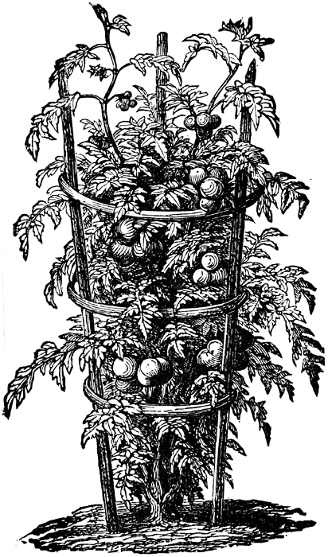
How many seeds/plants to a square?
Use also to “rate” your 16 favorite vegetables.
Save a square for herbs or flowers!

Beans: Bush – 9; Pole – 2 rows, 4” apart, 4 seeds each row for each square (need trellis)
Beets – 16
Broccoli – 1
Cabbage – 1
Carrots – 16
Cauliflower – 1
Swiss chard – 4
Corn – 4
Eggplant – 1
Lettuce (and other “greens”) – 4
Melons – 1 in 2 squares
Onions – 16
Parsley – 4
Peas – 2 rows 4” apart, 4 seeds each row for each square
Pepper – 1
Radishes – 16
Spinach – 9
Summer squash – 1 in a 3ft x 3ft space (cannot use in the 4ft x 4ft garden)
Winter squash – 1 in a 1ft x 2ft space
Tomatoes – 1 (need trellis)
Okra – 1
Space saver: A 1 square space planted with a large, long-season crop like tomatoes, can be inter-planted with fast-maturing crops such as lettuce or radishes that will be harvested before the tomato matures and needs the space.
Nashville Demonstration Organic Gardening
2017 “You-Can-Do-It” Square Foot Gardening

